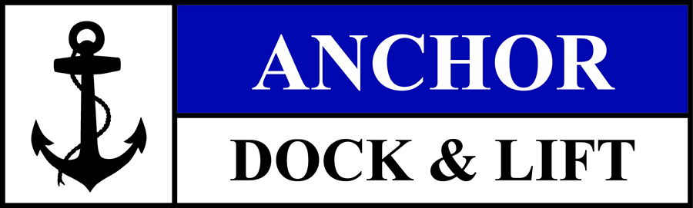

Position: Service Technician
Reports to Service Foreman

Description
We are a quickly growing small business that is growing our installation crews. Work outside on Minnesota lakes all summer! You will be installing docks and boat lifts in spring, servicing equipment in summer and removing docks and boat lifts in fall. Spring will have a lot of overtime and summer will be pretty laid back and fun. We are a fun and team-focused culture.

Summary of Duties:
* Complete installation, removal and servicing of various lakeshore equipment (docks and boat lifts, primarily)
* Pursue personal development - gain skills and knowledge necessary for outstanding performance in jobs and in life
* Support the corporate culture of Anchor Dock & Lift; hard working, fun, and service focused
* Exceed customer expectations with a focus on the “customer agenda”

Skill Set Requirements:
Must be able to lift 60lbs
- Ability to lift more is a benefit!
Must be proficient with basic tools
- Wrenches, Drills, Impact Wrench, sawzall, etc
Must be comfortable in and around the lakes in spring
- Must be comfortable on a boat, able to swim, and work in the water
- Be willing to work in poor weather conditions if needed
- Experience with boats and lakeshore equipment a benefit

Tools Required:
Basic wrench & ratchet set
Waders or wetsuit
Gloves

Compensation:
$15 probationary period (60 days)
Raises after 60 days based on performance
Benefits after full time and 9 months (Medical, Dental, 401k, profit sharing, PTO, etc)

Hours:
April 15 – June 15 Approximately 60 hours/week
June 15 – Oct 31 Approximately 40 hours/week
Nov 1 – March 1 As needed, based on performance, valued added, etc.

Start Date:
April 1st (Possibly earlier, depending on when ice is off the lakes)

